**Final Year Project proposal**

**guidelines and template**



*(Students are advised to use the project proposal template*

*available in this guideline to prepare their final year*

*project proposal document)*

**January, 2023**

**department of computing**

**abasyn university peshawar**

1. Introduction

Software development projects are an integral part of a computer science and software Engineering students’ career path. Once you attain the requisite knowledge and skills in software development, if you don’t put that knowledge and expertise to the test, they’ll be of little or no use. This is why it is mandatory for all final year undergraduate students of BSCS and BSSE to undertake Final Year Project (FYP) as a partial fulfilment in awarding bachelor degree from Abasyn University Peshawar.

Your final year project (FYP) is one of the most important aspects of your BS degree in CS & SE. FYP is one of the primary mechanisms used by the department to provide you an opportunity to gain experience in the practical, effective, efficient, and beneficial application of what you have been studying for the past several years. It is essential that you must learn from this exposure and practice all of the computer science and software engineering concepts and techniques.

The project is generally completed in two semesters in the time equivalent to two regular subjects (6 Cr. Hours). Ordinarily the project is an individual effort; however, group projects are possible if the work of the individuals can be evaluated separately. The project normally begins during the seventh semester and completed during the final semester. It is responsibility of the students to ensure both the deadlines and procedures described below are met and that all necessary documents are completed and in full compliance with the departmental and university requirements. The department can refuse to accept any thesis/ project that fail to meet these standards.

Read the following rules and regulations carefully before working on your proposal.

1. Project Registration Rules

Following are the basic rules and regulations that each group of students need to follow.

1. BS degree project is of 6 credit hours spread over two semesters (3 credit hours per semester).
2. Student must register FYP-I in the 7th semester and FYP–II in the 8th Semester.
3. The eligibility criterion for registration of the FYP is the completion of at least 100 credit hours by the end of 6th semester.
4. If the proposal is not submitted in the time specified, the individuals and each member (in a case of group) have to re-register FYP-I in the next semester.
5. In case, the project proposal is not approved, the students are provided with a specified time by the project coordinator to resubmit and represent another proposal.
6. In case the project is deferred, the students will be required make some amendments in the proposal and represent again within a specified time.
7. In case the proposal is deferred twice, then students need to re-register the FYP-I in the next semester.
8. Deadlines for proposal submission, Mid-term evaluation and Final submission would be announced by the FYP Coordinator.
9. The FYP Coordinator will notify the list of approved projects after the project proposal defense.
10. Regulations for Students
11. Each Student is required to work either in a group or individually.
12. Maximum FOUR (04) students are allowed in a group.
13. Each student is encouraged to propose some research topics and work on research-based project.
14. The students must ensure that the proposed project work is enough for each group member’s one-man year efforts.
15. Each student must meet his/her supervisor regularly at least once a week so that the progress of their work can be monitored closely.
16. Keep record of progress work using a logbook and ensure the supervisor to endorse the meeting form.
17. Students are strictly directed that they must NOT COPY or PURCHASE the project from the market and present it as their own.
18. Students are NOT allowed to use previously published project and claim it as their own.
19. If previous project work is being used and extended, then the supervisor must be informed and proper credit with reference to previous work, must be given. In such case, the extended version should have substantial contribution as compared to previous project work.
20. Students are NOT allowed to choose a topic proposed by one Supervisor, and switch to another supervisor with same topic, without the prior consent of the original supervisor.
21. Students must submit the ***Final Year Project Proposal*** document according to the prescribed template available subsequently in this document.
22. Ensure that there are no mistakes and errors (spelling, grammatical & formatting) in the proposal, before its submission.
23. Make two copies of FYP proposal, one for supervisor and one for your own reference.
24. Students are required to prepare project presentation and defend their chosen topic before the Evaluation Committee’s members.
25. Submission of Proposal
26. Proposal must be prepared according to the prescribed format available in this document.
27. Proposal must be signed by the supervisor.
28. Supervisor is required ensure that the student(s) has fulfilled all requirements and corrected all preliminary mistakes, errors and formatting issues in the proposal, before signing the final hardcopies.
29. Supervisor should not sign the proposal, if it is not according to the prescribed format.
30. Students shall submit the proposal with the supervisor.
31. Supervisors should forward the proposals to FYP Coordinator immediately.
32. Role of Evaluation Committee
33. The evaluation committee must analyze and assess the proposals according to the nature of each “individual’s contribution” to a group effort.
34. The committee must ensure that every individual must contribute at least one-man year efforts. (*A simple calculation of the number of man-hours in a year is 2,080 hours, without accounting for holidays.*)
35. The committee must ensure that each student should effectively contribute in the design, development, testing and implementation of the project. The student’s mere involvement in the design and/or documentation phase should be liable for rejection.
36. Every committee member should record his/her observations and recommendations on the prescribed form available at the end of the proposal document.
37. Committee must ensure that the project will be designed and developed using the latest tools, technologies and frameworks used in the software industry.
38. All committee members must sign the evaluation form.
39. Proposal Template Guidelines
40. Use the proposal template available in this document to write your project proposal.
41. Submit only project proposal related pages. **DO NOT** submit the guidelines pages with the proposal.
42. All sections and subsections of the proposal must be numbered, starting with number 1.
43. Page numbers must appear in the footer of the document.
44. All figures and tables should be numbered.

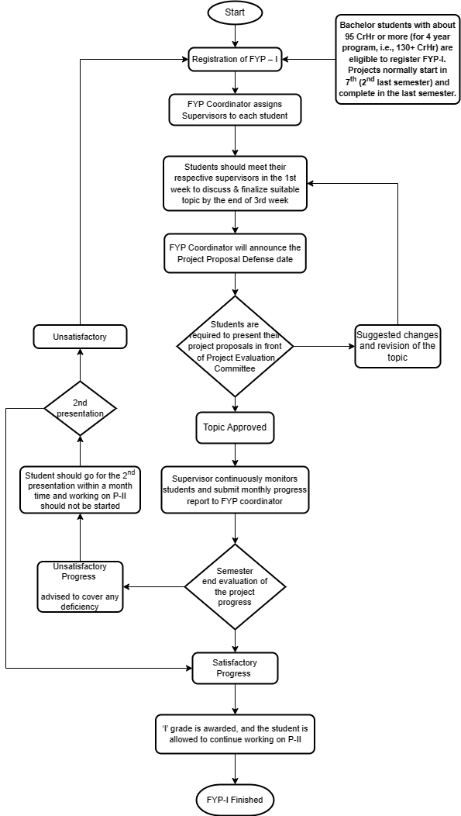

*This page is intentionally left blank*

**Project Title**

*The title must not be too long but must describe exactly what your project is about. Make your title specific and detailed. Stay within the 50-character limitation (Delete this text before submission)*



**Submitted By: Student Name**

**Registration No.**

**Supervised By: Teacher Name**

**Designation**

**Department of Computing**

**Abasyn University, Peshawar**

**October-2022**

**Department of Computing**

**Project Proposal Submission Form**

|  |  |  |  |  |  |  |  |  |  |  |
| --- | --- | --- | --- | --- | --- | --- | --- | --- | --- | --- |
| Project Title: | | |  | | | | | | | |
| Date of Submission | | |  | | | | | | | |
| Project Status  (Tick any one) | | | 🗆 New Proposal | | 🗆 Modification | | | | 🗆 Re-Submission | |
| **Students’ Information** | | | | | | | | | | |
|  | | **Student-1** | | **Student-2** | | | **Student-3** | | | **Student-4** |
| Reg. No. | |  | |  | | |  | | |  |
| Name | |  | |  | | |  | | |  |
| Contact No. | |  | |  | | |  | | |  |
| email | |  | |  | | |  | | |  |
| Signatures | |  | |  | | |  | | |  |
| **To be filled by the supervisor** | | | | | | | | **Specify the tools used** | | |
| 1. | Which method(s) used for requirement gathering? (Sec-2.1) | | | | | | |  | | |
| 2. | Which tool(s) used for requirements analysis process? (Sec-2.2 & 2.3) | | | | | | |  | | |
| 3. | Which software development model to be followed? (Sec-3) | | | | | | |  | | |
| 4. | Which tool(s) will be used for system design? (Sec-4) | | | | | | |  | | |
| 5. | Which technologies will be used for the system development? (Sec-5) | | | | | | |  | | |
| 6. | Which tool(s) is used for Work Breakdown Structure (WBS)? (Sec-7) | | | | | | |  | | |
| 7. | What is each student’s contribution in terms of man month as mentioned in WBS? (Sec-7) | | | | | | |  | | |
| Name of Supervisor | |  | | | | Supervisor Signature | |  | | |

**Table of Contents**

Topics Page No.

1. Introduction and Background of the Project 1
2. Requirement Analysis Process 2
3. Software Development Process Models 3
4. System Design 4
5. Technology Requirements 5
6. Project Deliverables 6
7. Work Breakdown Structure 7
8. References 8
9. Proposal Evaluation Form 9
10. **Introduction and Background of the Project**

Write a brief introduction and background of your project. In [this section](http://explorable.com/how-to-write-an-introduction.html) it is important to give the reasons why you have picked this topic. Justify your proposal with background information about the field that led to undertake this problem. Describe the purpose, motivation or relevance of the project. Describe why the problem is important. You must convey why you want to take this project and what you hoped to learn from this project.

When putting together the project background, it’s critical to explain the current state of the problem and why your audience should care about solving it. Using references and statistics in this section can be helpful in getting your point across effectively.

1. **Requirement Analysis Process**

Requirements analysis is a set of operations that helps define users' expectations of the application you are building or modifying. Software engineering professionals sometimes call it requirement engineering, requirements capturing or requirement gathering.

This process involves analyzing, documenting, validating and managing system or software requirements. Requirements analysis involves various tasks that help engineers understand stakeholder demands and explain them in simple and visual ways. It is essential to a software or system project's success.

**2.1 Gather the requirements**

To begin the requirements analysis process, communicate with users to gather the requirements. This phase is also known as "eliciting requirements." Analysts can use different techniques to gather the requirements, including:

1. Conducting interviews
2. Observing the workplace
3. Holding focus groups or workshops
4. Creating requirements lists

**2.2 Analyze the requirements**

The developers make sure the requirements are achievable and understandable. Then you can determine if the listed requirements are contradictory, incomplete, unclear or ambiguous, and solve those problems. The goal of this phase is to decompose, analyze and detail the requirements across the system's design. Common requirements analysis techniques include:

1. Business process modeling notation (BPMN)
2. Gap analysis
3. Flowchart technique
4. Unified modeling language (UML)
5. Role activity diagrams (RAD)
6. Integrated definition for function modeling (IDEF)
7. Gantt charts
8. Data flow diagram

**2.3 Requirement Analysis Tool(s) Used**

Requirements analysis can be performed successfully by using the right set of tools. Here are some of the most popular ones:

1. Jama Software
2. Caliber
3. Visure Requirements
4. Orcanos
5. Modern Requirements
6. IBM Engineering Requirements Management DOORS Next
7. Accompa
8. ReqSuite
9. Perforce Helix RM
10. Pearls
11. **Software Development Process Models**

In the development of software, there are different models employed in the process development of software, known as Software Development Models. This section provides insight on what process model you will employ in the development of the proposed system. Identify which software development process model such as, ***Agile model, waterfall model, RAD model, Spiral model, V model, Incremental model and Rational Unified Process*** is best for your project and why you have chosen this?

1. **System Design**

In this phase, every fact of the system is considered in detail. Here is a list of some procedures for the detailed design of system activities.

1. Output design
2. Interface (Input) design
3. Systems processing (System flowchart, Data Flow Diagrams)
4. Files and databases (ERD, Relational Database Schema & Normalization)
5. High-Level Component Design
6. Systems controls and backup (Security)

Students must use any of the following tool for design purpose:

1. UXPin
2. Zeroheight
3. Supernova
4. Storybook
5. Pattern Lab
6. Adobe XD
7. Design System Manager – InVision
8. Vue Design System
9. Carbon
10. Grommet
11. **Technology Requirements**
12. Software development can be a long and arduous journey. To ease some of the complications and simplify the path, it is important to take advantage of useful tools to improve workflow and productivity with great outcomes. There are many options when it comes to which software or platform you decide to use to complete your intended project. The project proposal must clearly specify the tools and technologies to be used in the project such as:
13. Primary Programming Language
14. Integrated Development Environments (IDEs)
15. Database Management System
16. Tools for Software Testing
17. Tools for Project Management and Communication
18. Version Control System
19. The students are encouraged to use latest tools and technologies to develop their proposed systems. The must select tools from the following recommended list.

**Programming Languages:** Python, JavaScript, Flutter, React, React Native, Angular, Node.js, Kotlin, Swift, R, Ruby, TypeScript, Scala, NoSQL, Rust, Perl

**Software Development Tools:** Collaborator, Studio 3T, Linx, DbSchema, GitHub, Apache NetBeans, AWS Cloud9, Codenvy, Atom, CodeLobster, Bootstrap, Azure, BitBucket, ClickUp, Jira, SendBird, Crimson, Docker, Axure.

1. **Project deliverables**

Deliverables are the outcomes of a completed project (i.e. products, services or a detailed report). Mention your project deliverables along with delivery dates. Use a work breakdown structure here to help the stakeholders get a clearer picture.

1. **Work Breakdown Structure**

A Work Breakdown Structure (WBS) is a table that identifies and lists project components and deliverables. In project management WBS is a method for completing a complex, multi-step project. WBS is used to organize a project team’s tasks and duties into small chunks of goals. Breaking it down into smaller chunks means work can be done simultaneously by different team members, leading to better team productivity and easier project management. It enables all the stakeholders to estimate the total time and resource consumption in a particular software development project.

In this section you are required the prepare the **WBS** showing clearly:

1. The sequence of tasks to be completed
2. Task assignment and the people responsible for it
3. The timeline for the aforementioned tasks and the project deadline
4. Identify task dependencies
5. Showing project milestones and deliverables

Students must prepare WBS by using any of the following tools. ***Hand drawn simple table is not acceptable***.

1. OpenProject
2. Monday
3. Lucidchart
4. Praxie
5. Creately
6. **References**
   1. __________________________________________________________________

(*For Office Use Only*)

**Department of Computing**

**FYP-1 Evaluation Form**

Student Name(s):

|  |  |  |  |
| --- | --- | --- | --- |
|  |  |  |  |

Project Title:

|  |
| --- |
|  |

**Evaluation Committee Member’s**

|  |  |  |
| --- | --- | --- |
| Remarks: | | |
|  | | |
|  | | |
| 🗆 Recommended | 🗆 Deferred for modifications | 🗆 Re-Present |
| Name of Member-1 | Signature | Date |
|  |  |  |

|  |  |  |
| --- | --- | --- |
| Remarks: | | |
|  | | |
|  | | |
| 🗆 Recommended | 🗆 Deferred for modifications | 🗆 Re-Present |
| Name of Member-2 | Signature | Date |
|  |  |  |

|  |  |  |
| --- | --- | --- |
| Remarks: | | |
|  | | |
|  | | |
| 🗆 Recommended | 🗆 Deferred for modifications | 🗆 Re-Present |
| Name of Member-3 | Signature | Date |
|  |  |  |

**Committee Head**

|  |  |  |
| --- | --- | --- |
| Remarks: | | |
|  | | |
|  | | |
| 🗆 Recommended | 🗆 Deferred for modifications | 🗆 Re-Present |
| Head of Committee Name | Signature | Date |
|  |  |  |